**INDEX**

**Topic Name:**

List of Abbreviations 3

List of Figures 4

Abstract 5

**Chapter 1** (Introduction and Problem Definition) 6

1.1 Introduction 7

1.2 Problem Definition 8

**Chapter 2** (System Design) 9

2.1 Data Flow Diagram 10

2.2 UML Diagrams 11

• Activity Diagram 11

• Use Case Diagram 12

**Chapter 3** (Modules of Web Application) 13

3.1 Description Of Each Module 14

**Chapter 4** (Implementation Details) 16

4.1 Code 17

4.2 Software Requirement 24

4.3 Technology Used 25

**Chapter 5** 27

5.1 Screenshots 28

**Chapter 6** (Application & Advantages / Disadvantages) 31

6.1 Application 32

6.2 Advantages & Disadvantages 32

**Chapter 7** 33

7.1 Future Scope 34

7.2 Conclusions 35

7.3 Reference 36

**LIST OF ABBRIVIATIONS:**

**Sr. no Abbreviations Description**

1. HTML Hyper Text Markup Language

2. CSS Cascading Style Sheets

3. PHP Hypertext Pre-Processor

4. JS Java Script

5. My-SQL Structured query language.

**LIST OF FIGURES:**

­

1 DFD Data Flow Diagram

2 AD Activity Diagram

3 UML Unified Modeling Language

**ABSTRACT:**

As the name specifies “CRIME INVESTIGATION TRACKER WITH SUSPECT PREDICTION” is a website developed for serving the services like live website and manages various activities has been done by the user. Whenever a case against the crime is filed the investigation always starts from the scratch right away from the evidences found at the crime location and the eye witnesses present at the crime location. On the basis of the statement given by the eye witnesses about the crime and the criminal who committed that crime. The process of the investigations starts.

As to reduce the stress of the police officers we implemented a system as criminal investigation tracker with suspect prediction that will help the officers to speed up the process of investigation and track status of ongoing case by predicting out the primary suspects on the basis of the records which consists of compendium of the people associated to the case, former criminal background proofs recovered from crime location, etc. This digitized system makes the work easy for an officer to check the status of the case online and even allows him to add up the new important information related to the case as it's when needed. The proposed system consists of suspect prediction algorithm to predict and suggest the suspects in the logical order.

**CHAPTER -1**

**(INTRODUCTION AND PROBLEM DEFINATION)**

* 1. **Introduction:**

Crime is an awful and illegal act against law for doing wrong things out of which someone can be punished by police authorities and government. A criminal is a person who has committed or is involved with any kind of crime. Crimes are a social nuisance and cost our society nearly in several ways. In our society the crime rate is growing very rapidly especially women are facing many of such crime problems. The reason for this might be the low pronouncement of guilt. About 10% of criminals commit 50% of crimes. This system helps in keeping over the patterns in crime scenario i.e. whether it is increasing or decreasing and if increasing then what are the problem areas. The first phase of the project gives the brief overview of the project and its objective. The main objective is to find and predict the probable suspect for the unsolved cases from the criminal records present in the database in the system. Here, in the initial stage the admin adds the officer to the system and then add them to a particular case that they are going to investigating individually. As the Officers are added to a particular case, the officer will add the details of the criminal in their database and once the information related to the criminal is over then the second phase would began. The second phase concentrates mainly over shaping the project towards its ultimate goal. Once, the data of criminal is added to the database the officers files the FIR and all the details of the victim and criminal is added. Herein, we concentrate on predicting the crime, how the crime had taken place with the help by using the decision tree algorithm

Their growth, depreciation and other associated results conceming the crime Manage scenario. On the basis of the case type, belongings, land properties, relationships and other such aspects associated with the former crime logs involved and based on the respective information the prominent suspects are predicted and are suggested in a logical order.

* 1. **Problem Definition:**

This web site is Design in favor of crime investigation which helps to the officer to find crime related information in one website. They can share their crime report and save others report in a websites for that they have to just login first time to create there profile.

The website will help to officer to find crime investigation related information to share their record, data to communicate other officer. They can share their opinion on website

**CHAPTER -2**

**(SYSTEM DESIGNED)**

**2.1 DFD**

• **LEVEL -0 DATA FLOW DIAGRAM:**

A data-flow diagram is a way of representing a flow of data through a process or a system The DFD also provides information about the outputs and inputs of each entity and the process itself. User first open sport fever website then see login page for the authentication and users keep proper ID And Password for entering site,so users ID & Password send request to site and site response this users request after authentication users provide site services such as posts, by this services such as posts ,by this service users can share their individual post though request response model by their ID .And uploading post on this site managed by photo management And last one Admin who role for security of this site.

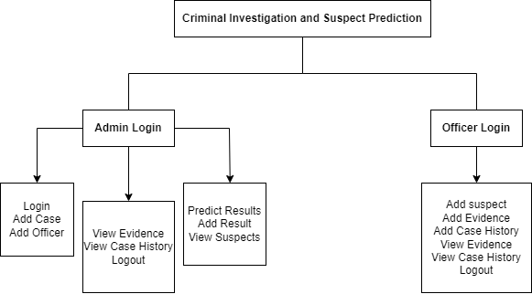

**2.2 ACTIVITY DIAGRAM :**

First of all user open the page. If he is new for our website he has to register first with his name and strong password after registration he becomes an authenticate user of website. Whenever user want to login he has to enter his login id and password he entered on registration time our server match the login id and password if it is wrong user get invalid user id or password and redirect to the login page again if password and user id is correct user jump to the next page and enter to the home page of our website. After that user can do various activities like check his profile, upload a image can visit others profile watch their post like the post comment on the post and so on. After all if user want to logged out from website for security purposes so he can logged out.

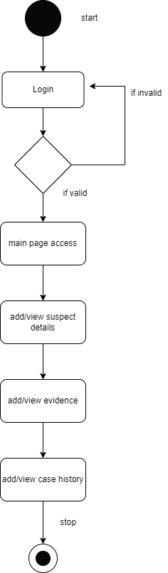

**2.3 USE CASE DIAGRAM :**

In our website the communication has taken between user and server. User start the page for first user registered in website server store all the data provided by user for the future. When user login in the website he entered on home page of website. User can visit others post like the post and comments on the post and server store all activities done by the user. User can upload sports related post on his profile and server store it. When user again login he can get all the post that he uploaded before logged out from website. Server is working like database server is managing data and save if user accidentally delete his post or data so he can retrieve it from servers using I'd and password. User can customize his website server save all customized data. After all if user have to logged out server get the action from user and signed out. But server ensure to user that his data never loss unless server get fail.

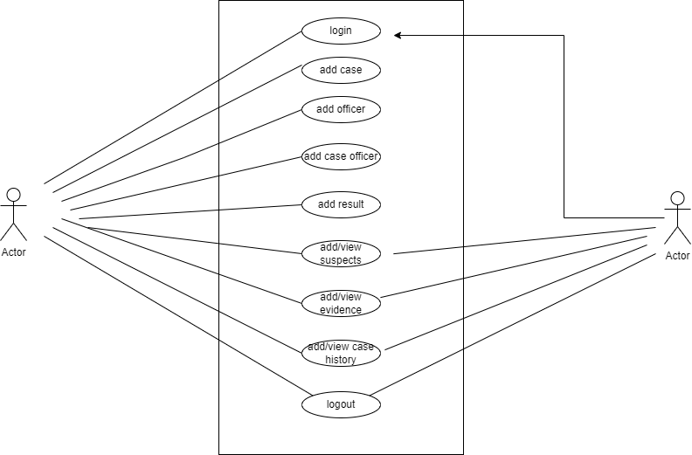



* 

**CHAPTER -3**

**(MODULE OF WEB APPLICATION)**

**3.1 MODULES:**

• LOGIN & REGISTRATION

• HOME

• POST

• PROFILE & SETTING

• ABOUT US

• LOGOUT

**3.1.1 LOGIN & REGISTRATION:**

The OFFICER Needs to create the officer login ID .It is most important module/step for the website. It will store the records of officer that he we access in the websites whatever the record he share or saved all the records will save in database through login ID. Users have to complete his registration first and then he will able to login for website. For Security Purpose it is necessary.

**3.1.2 HOME:**

When Login will completed the first page will be Home page. This module will constant for every page that will make very easier to user to jump directly on Home page from any page. It is very important module because all the information and posts will be on Home page.

**3.1.3 POST:**

This module will help to user to share information pictures and clip on website.

**3.1.4 PROFILE & SETTING:**

For any user the profile is very important it gives identity for particular people. In this Module there will be information of the user For Security purpose if user have to delete previous data and cache data or permanently delete the amount so user can use setting module.

**3.1.5 ABOUT US:**

Here will be the information and description of the website and profiles of the Developers. Whatever the help user want from developer. They can contact.

**3.1.6 LOGOUT :**

For the security purpose and after using website user can logout. After Login again user will able to access his account without losing the data on the website.

**CHAPTER -4**

**(IMPLIMENTATION DETAILS)**

**4.1 CODE:**

**4.1.1 LOGIN FORM:**

@extends('layouts.crime')

@section('content')

    <h1 class="form-title">login</h1>

    <form action="{{ route('login') }}" method="POST" class="login-form">

        @csrf

        <div class="group">

            <label class="form-label" for="email">Email Address</label>

            <input type="email" id="email" type="email" class="form-input @error('email') is-invalid @enderror" name="email"

                value="{{ old('email') }}" required autocomplete="email" autofocus>

            @error('email')

                <span>

                    <small style="font-size:12px;color:red">{{ $message }}</small>

                </span>

            @enderror

        </div>

        <div class="group">

            <label class="form-label" for="email">Password</label>

            <input type="password" id="password" type="password" class="form-input @error('password') is-invalid @enderror"

                name="password">

            @error('password')

                <span>

                    <small style="font-size:12px;color:red">{{ $message }}</small>

                </span>

            @enderror

        </div>

        <div class="group">

            <input class="form-check-input" type="checkbox" name="remember" id="remember"

                {{ old('remember') ? 'checked' : '' }}>

            <label class="form-check-label" for="remember">

                {{ __('Remember Me') }}

            </label>

        </div>

        <button class="form-btn">login</button>

    </form>

    <a href="/" class="login-btn">back</a>

@endsection

4.1.2 HOME PAGE :

@extends('layouts.app')

@section('content')

<div class="container">

    <div class="row justify-content-center">

        <div class="col-md-8">

            <div class="card">

                <div class="card-header">{{ __('Dashboard') }}</div>

                <div class="card-body">

                    @if (session('status'))

                        <div class="alert alert-success" role="alert">

                            {{ session('status') }}

                        </div>

                    @endif

                    {{ __('You are logged in!') }}

                </div>

            </div>

        </div>

    </div>

</div>

@endsection

LAYOUT PAGE:

<!DOCTYPE html>

<html lang="en">

<head>

    <meta charset="UTF-8">

    <meta name="viewport" content="width=device-width, initial-scale=1.0">

    <meta http-equiv="X-UA-Compatible" content="ie=edge">

    <title>Crime Investigation</title>

    <link rel="stylesheet" href="{{ asset('css/app.css') }}">

    <link rel="stylesheet" href="{{ asset('css/crime.css') }}">

</head>

<body>

    <div class="video-overlay">

        <video loop autoplay muted src="{{ asset('videos/evidence.mp4') }}" type="video/mp4"></video>

    </div>

    @yield('content')

</body>

</html>

**USERADMIN PAGE:**

<!DOCTYPE html>

<html lang="en">

<head>

    <meta charset="UTF-8">

    <meta name="viewport" content="width=device-width, initial-scale=1.0">

    <meta http-equiv="X-UA-Compatible" content="ie=edge">

    <title>Admin Panel | {{ env('APP_NAME') }}</title>

    <!-- CSS only -->

    <link rel="stylesheet" href="https://cdnjs.cloudflare.com/ajax/libs/font-awesome/6.1.1/css/all.min.css"

        integrity="sha512-KfkfwYDsLkIlwQp6LFnl8zNdLGxu9YAA1QvwINks4PhcElQSvqcyVLLD9aMhXd13uQjoXtEKNosOWaZqXgel0g=="

        crossorigin="anonymous" referrerpolicy="no-referrer" />

    <link href="https://cdn.jsdelivr.net/npm/bootstrap@5.1.3/dist/css/bootstrap.min.css" rel="stylesheet"

        integrity="sha384-1BmE4kWBq78iYhFldvKuhfTAU6auU8tT94WrHftjDbrCEXSU1oBoqyl2QvZ6jIW3" crossorigin="anonymous">

    <link rel="stylesheet" href="{{ asset('css/crime.css') }}">

</head>

<body>

    <div class="video-overlay">

        <video loop autoplay muted src="{{ asset('videos/investigation.mp4') }}" type="video/mp4"></video>

    </div>

    <main class="container-fluid" id="panel">

        <div class="row">

            <div class="col-md-2 sidebar">

                <div class="sidebar-card">

                    <div class="user-type">

                        <a href="#">Admin Panel</a>

                    </div>

                    @php

                        $admin_links = [

                            [

                                'name' => 'suspects',

                                'route' => 'officer.suspects.index',

                                'icon' => 'fa-solid fa-house',

                            ],

                            [

                                'name' => 'evidence',

                                'route' => 'officer.evidences.index',

                                'icon' => 'fa-solid fa-building',

                            ],

                            [

                                'name' => 'case history',

                                'route' => 'officer.history.index',

                                'icon' => 'fa-solid fa-square-poll-horizontal',

                            ],

                        ];

                    @endphp

                    <i class="fa-solid fa-square-poll-horizontal"></i>

                    <ul>

                        @foreach ($admin_links as $link)

                            <li>

                                <a href="{{ route($link['route']) }}"

                                    class="{{ request()->routeIs($link['route']) ? 'active' : '' }}"><i

                                        class="{{ $link['icon'] }}"></i>&nbsp;&nbsp;{{ $link['name'] }}</a>

                            </li>

                        @endforeach

                        <li>

                            <form action="{{ route('logout') }}" method="POST">

                                @csrf

                                <button><i class="mr-2 fas fa-power-off"></i>&nbsp;&nbsp;Logout</button>

                            </form>

                        </li>

                    </ul>

                </div>

            </div>

            <div class="col-md-10 main-content mt-3" style="overflow-y: scroll;height:700px">

                @yield('content')

            </div>

        </div>

    </main>

</body>

</html>

**ADMIN PAGE CODE :**

<!DOCTYPE html>

<html lang="en">

<head>

    <meta charset="UTF-8">

    <meta name="viewport" content="width=device-width, initial-scale=1.0">

    <meta http-equiv="X-UA-Compatible" content="ie=edge">

    <title>Admin Panel | {{ env('APP_NAME') }}</title>

    <!-- CSS only -->

    <link rel="stylesheet" href="https://cdnjs.cloudflare.com/ajax/libs/font-awesome/6.1.1/css/all.min.css"

        integrity="sha512-KfkfwYDsLkIlwQp6LFnl8zNdLGxu9YAA1QvwINks4PhcElQSvqcyVLLD9aMhXd13uQjoXtEKNosOWaZqXgel0g=="

        crossorigin="anonymous" referrerpolicy="no-referrer" />

    <link href="https://cdn.jsdelivr.net/npm/bootstrap@5.1.3/dist/css/bootstrap.min.css" rel="stylesheet"

        integrity="sha384-1BmE4kWBq78iYhFldvKuhfTAU6auU8tT94WrHftjDbrCEXSU1oBoqyl2QvZ6jIW3" crossorigin="anonymous">

    <link rel="stylesheet" href="{{ asset('css/crime.css') }}">

</head>

<body>

    <div class="video-overlay">

        <video loop autoplay muted src="{{ asset('videos/crime.mp4') }}" type="video/mp4"></video>

    </div>

    <main class="container-fluid" id="panel">

        <div class="row">

            <div class="col-md-2 sidebar">

                <div class="sidebar-card">

                    <div class="user-type">

                        <a href="#">Admin Panel</a>

                    </div>

                    @php

                        $admin_links = [

                            [

                                'name' => 'cases',

                                'route' => 'admin.cases.index',

                                'icon' => 'fa-solid fa-house',

                            ],

                            [

                                'name' => 'officers',

                                'route' => 'admin.officer.index',

                                'icon' => 'fa-solid fa-building',

                            ],

                            [

                                'name' => 'case history',

                                'route' => 'admin.history.index',

                                'icon' => 'fa-solid fa-square-poll-horizontal',

                            ],

                            [

                                'name' => 'predict result',

                                'route' => 'admin.predict.index',

                                'icon' => 'fa-solid fa-square-poll-vertical',

                            ],

                            [

                                'name' => 'add result',

                                'route' => 'admin.result.index',

                                'icon' => 'fa-solid fa-plus',

                            ],

                        ];

                    @endphp

                    <i class="fa-solid fa-square-poll-horizontal"></i>

                    <ul>

                        @foreach ($admin_links as $link)

                            <li>

                                <a href="{{ route($link['route']) }}"

                                    class="{{ request()->routeIs($link['route']) ? 'active' : '' }}"><i

                                        class="{{ $link['icon'] }}"></i>&nbsp;&nbsp;{{ $link['name'] }}</a>

                            </li>

                        @endforeach

                        <li>

                            <form action="{{ route('logout') }}" method="POST">

                                @csrf

                                <button><i class="mr-2 fas fa-power-off"></i>&nbsp;&nbsp;Logout</button>

                            </form>

                        </li>

                    </ul>

                </div>

            </div>

            <div class="col-md-10 main-content mt-3" style="overflow-y: scroll;height:700px">

                @yield('content')

            </div>

        </div>

    </main>

</body>

</html>

**4.2 SOFTWARE REQUIREMENT:**

**4.2.1 Operating System:**

• Windows 10 is the latest operating system from Microsoft for personal computer officially unveiled in 2014 it introduces the idea of rolling updates to the operating system. Windows 10 was released to consumers on the 29th July 2015 as the successor to windows 9.

**4.2.2 Browser:**

• Browser software that allows a computer user to find and view information on the internet web browser interpret HTML tags in download document and format the displayed data according to a set of standard style rules

• Here we are use browser as platform to run our program to displayed the output of the website which we are making

• When we will request our web page to the browser the browser retrieve the necessary content and displayed the page on the user device.

**4.3 TECHNOLOGIES USED:**

**4.3.1 Frontend Language:**

• **HTML**

HTML (Hyper Text Markup Language) is the basic building block of the web. It designed the meaning and structure of web content. HTML tell the browser how to display the content.

• **CSS**

CSS (Cascading Style Sheets) fondly referred to as CSS. Is a simple designed language intended to simplify the process of making web pages presentable.CSS allows applying style to web pages. CSS saves a lot of work. It can control the layout of multiple web pages all at once.

• **Bootstrap5**

Bootstrap 5 is the newest version of Bootstrap, which is the most popular HTML, CSS, and JavaScript framework for developing responsive, mobile-first website

**4.3.2 Backend Language:**

**• PHP**

PHP (Hypertext Pre-Processor) is a scripting language used to develop static and dynamic webpage and web applications. It is one of the most widely used server-side scripting language in a web development. PHP is so popular because it’s very easy to learn code and deploy on server hence it has been the first choice for beginners since decades.

• **JavaScript**

JavaScript is a very powerful client-side scripting language Java script is mainly used for enhancing the interaction of a user with the web page. Java script is most used for designing interactive webpage. Java script was developed by Brendan Eich in 1995 which appeared in Netscape, a popular browser of the time .

**• My-SQL**

My-SQL is an open source relational database management system. Its name is a combination of ”My” the name of co-founder Michael Widenius’s daughter, and “SQL” the abbreviation of Structured query language.

**4.3.3 Hardware Requirement:-**

Processor: Intel Pentium duo-core 2.4 GHz

RAM: 500 Mb

Hard Drive: Minimum 500 GB

**CHAPTER -5**

**(SCREENSHOTS)**

MAIN PAGE:



LOGIN PAGE:

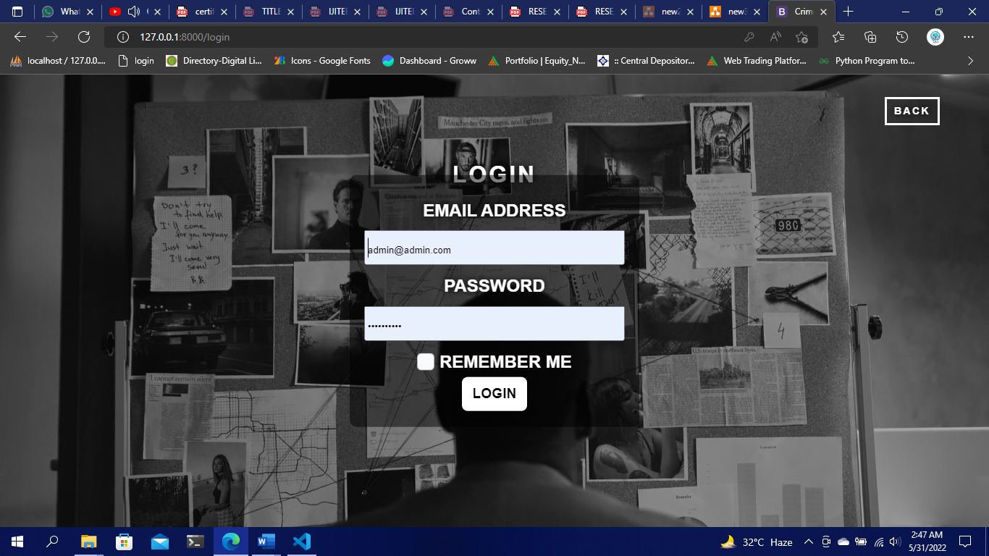

ADMIN PAGE:

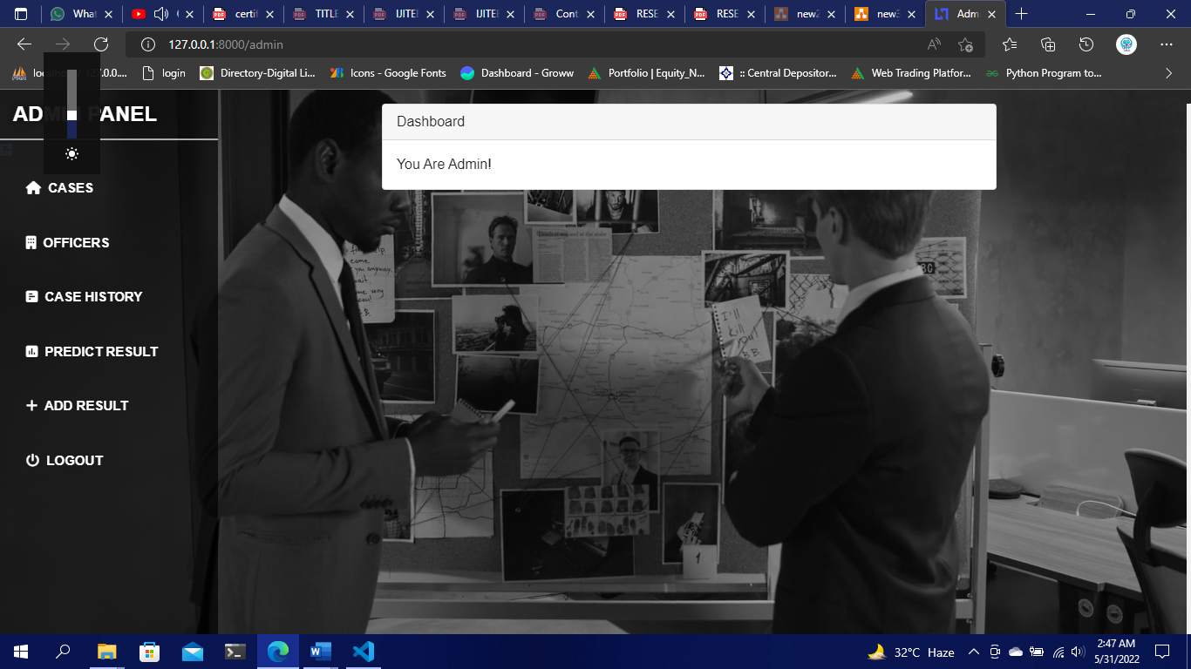

CASE ADD:

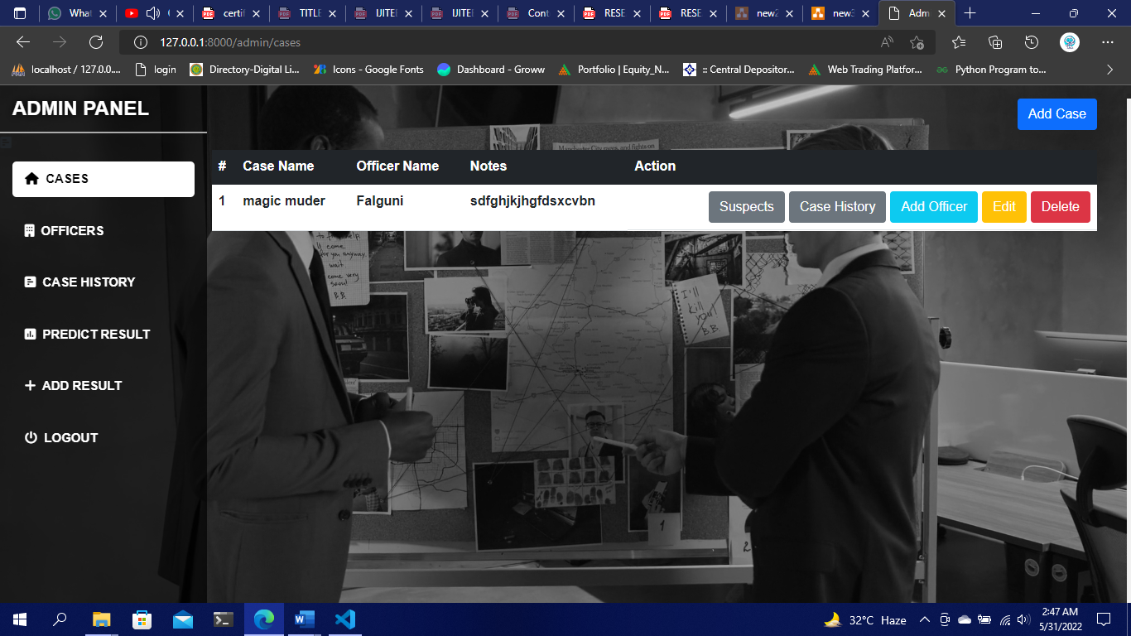

SUSPECT PAGE:

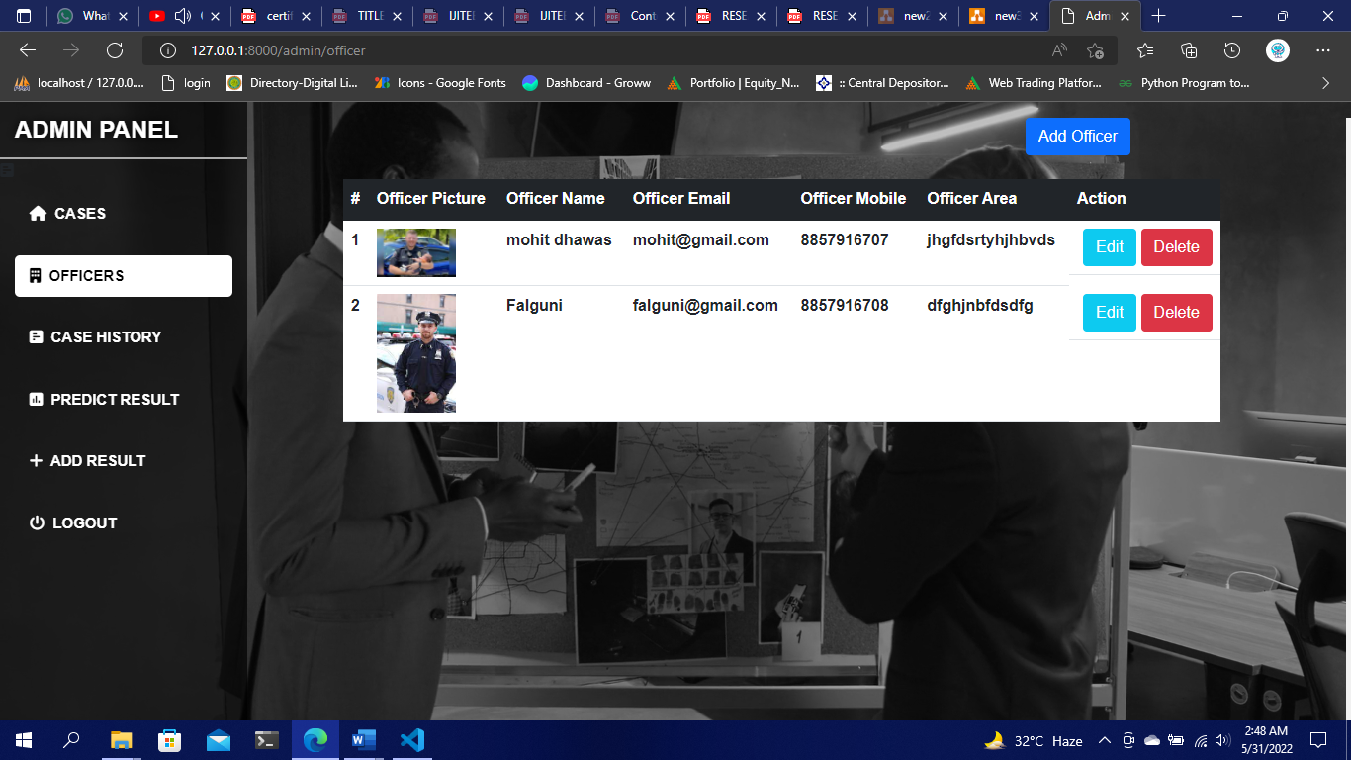

**CHAPTER -6**

**(APPLICATION & ADVANTAGES / DISADVANTAGES)**

**Advantages:**

* The software will be very useful for government agencies.
* The software allows for team work on solving complicated cases.
* Individual investigation teams in different teams can keep track and coordinate on cases.
* Will help in solving cases faster and efficiently

**CHAPTER -7**

**(FUTURE SCOPE,CONCLUSIONS,REFERENCE)**

­­­­­­­

**7.1 FUTURE SCOPE :**

The development of these techniques and models are really vast. The crime tracker model can be developed if we want to identify a particular criminal out of a record . And method can be developed in such a way it can act like a real without westing a time. The development can be in such a way it can be training that will help for a better performed model.

The Models can be developed in different ways by using some latest packages of Laravel that will help us to give commands which will identify an input and perform some function on the system. So if any separate criminal is detected it can perform special function or if an input from user is detected it will open any specific folder with ease without performing any actions.

**7.2 CONCLUSION:**

The need for a computerized platform for crime record management cannot be overemphasized. The criminal investigation tracker enchances proper and efficient management of criminal records, thereby helping in making informed decisions and improving reliability thus improving law enforcement operation. This results in lower crime rate in the country thereby increasing national security.

**7.3 REFERENCE :**

[1] Bogomolov, Andrey and Lepri, Bruno and Staiano, Jacopo and Oliver, Nuria and Pianesi, Fabio and Pentland, Alex.2014. Once upon a crime: Towards crime prediction from demographics and mobile data, Proceedings of the 16th International Conference on Multimodal Interaction.

[2] Yu, Chung-Hsien and Ward, Max W and Morabito, Melissa and Ding, Wei 2011 Crime forecasting using data mining techniques, pages 779-786, IEEE 11th International Conference on Data Mining Workshops (ICDMW)

[3] Kianmehr, Keivan and Alhajj, Reda. 2008. Effectiveness of support vector machine for crime hot-spots prediction, pages433-458, Applied Artificial Intelligence, volume 22, number 5.

[4] Toole, Jameson L and Eagle, Nathan and Plotkin, Joshua B. 2011 (TIST), volume 2, number 4, pages 38, ACM Transactions on Intelligent Systems and Technology.

[5] Wang, Tong and Rudin, Cynthia and Wagner, Daniel and Sevier, Rich. 2013 pages 515530, Machine Learning and Knowledge Discovery in Databases.

[6] Friedman, Jerome H. "Stochastic gradient boosting" Computational Statistics and Data Analysis 38.4 (2002): 367 378 sts [7]Leo Breiman, Random Forests. Machine Learning. 2001, Volume 45. Number 1, Page 5